Your title FOR Bioencapsulation CONTRIBUTION : maximum 2 lines  Authors – Lastname, initials, Affiliation, Country (Doe, J., Encapsol, France) | 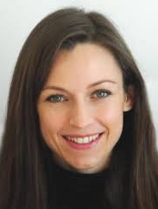

READ Before to start
The present template must be used for preparing your contribution. Contributions that will not follow the guidelines will be sent back to the author.
Your text should fit as much as possible one page but only one page. Documents must not exceed 2 megabytes. If needed, use the function “File size reduction” from the “file” menu.
Text must in Arial 10. Do not include blank lines between paragraphs and paragraph indentations. A small space will be automatically included between paragraphs.
Use the BRG styles to build your text on top menu or open the style pane. Copy and paste the tables and figures from the template and replace their content.
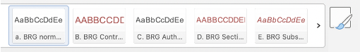
BRG style menu. You may also open the style pane on right of the menu.
Header
Keep your title short, maximum 90 characters. List authors (max 4) and short FIRST author affiliation. First author MUST BE the participant who submits the text. First author picture should replace the one on top right.
Section
Your text should be subdivided in the following sections. Section title is in UPPER CASE RED :
Introduction & Objectives
Material & Methods
Results & Discussion
Conclusions & Perspectives
References
When applicable an acknowledgement section may be added at the end of the document.
Subsection
You may subdivide the sections in subsections. Their title should be in red, italic and bold:
Tables
Legend of the table: should always be placed at the top.
header | Alginate | Starch | PEG | Total
Cell 1
Cell 2

While possible use a figure instead of a table. Copy and pass the table below at the desired place inside the text. You may add columns and rows to fit with your needs. Replace title, header and cell content, keeping the style. However, limit the number of rows and columns of your table.
Figures
Copy and paste the figure below (embedded in a table) at the desired place inside the text. Replace the figure modify the legend keeping the style. Do not modify the size neither the style of the table.
Figures are an attractive part of your contribution. It is advisable to use high quality, colourful images. The hard copies of the proceedings are printed in high quality (600 dpi). Figures are included in a single-cell table to provide the red frame.
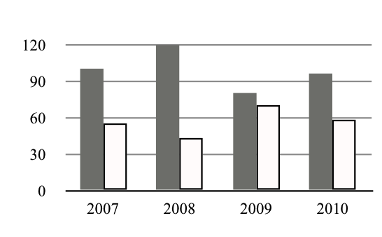
Figure must be inserted in a single cell table to get a red border. You could simply copy the table above and replace his content. Figure legends should be placed below the figure.
References (maximum 3)
Do not use more than 3 references. References should be included in the text as (first author’s name, year).
We recommend reading the following articles.
Whitesides G.M. Writing a Paper, Adv. Mater. 2004, 16 (15) 1375-1377.
Patience G.S., et al. (2014) Writing a Scientific Paper: From Clutter to Clarity. https://onlinelibrary.wiley.com/pb-assets/assets/1939019x/2014_01_15_Manuscript_preparation.pdf.
Acknowledgements
You may add a short section for acknowledgements
Affiliation
Include the affiliations of other authors (keep it very short)

